**D.SARATH BABU-192311031**

**EXP 9: CREATE A VIRTUAL HARD DISK AND ALLOCATE THE STORAGEUSING VM WARE WORKSTATION.**

**DATE:**

**AIM:**

To create a virtual hard disk and allocate the storage using vm ware workstation

**PROCEDURE:**

**STEP 1:**GOTO VM WARE WORKSTATION.

**STEP2:** RIGHT CLICK THE VM AND GOTO THE SETTINGS.

**STEP 3:** ADD HARDWARE WIZARD AND SELECT SCSI AND CLICK NEXT.

**STEP 4:** CREATE NEW VIRTUAL DISK.

**STEP 5:** SELCT THE DISK SIZE AS 2.0. AND SELCT SPLIT VIRTUAL DISK INTOMULTIFILES.

**STEP 6:** GIVE NAME AND CLICK THE FINISH.

**IMPLEMENTATION:**

**STEP 1:GOTO VM WARE WORKSTATION**

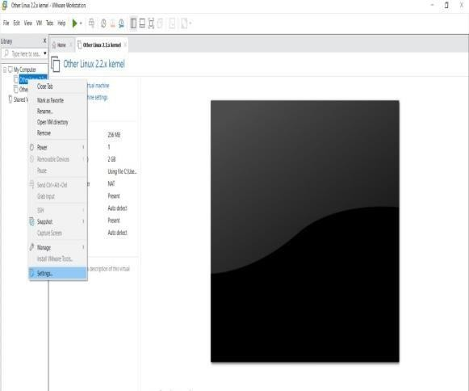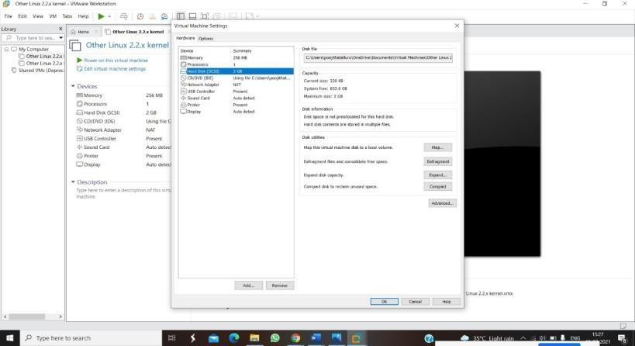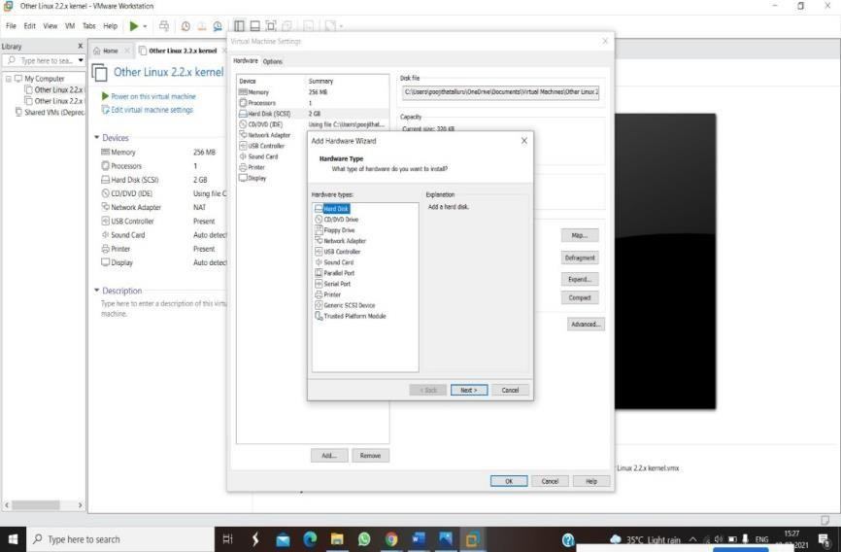**STEP2: RIGHT CLICK THE VM AND GOTO THE SETTINGS**

**STEP 3: ADD HARDWARE WIZARD AND SELECT SCSI AND CLICK NEXT**

**STEP 4: CREATE NEW VIRTUAL DISK**

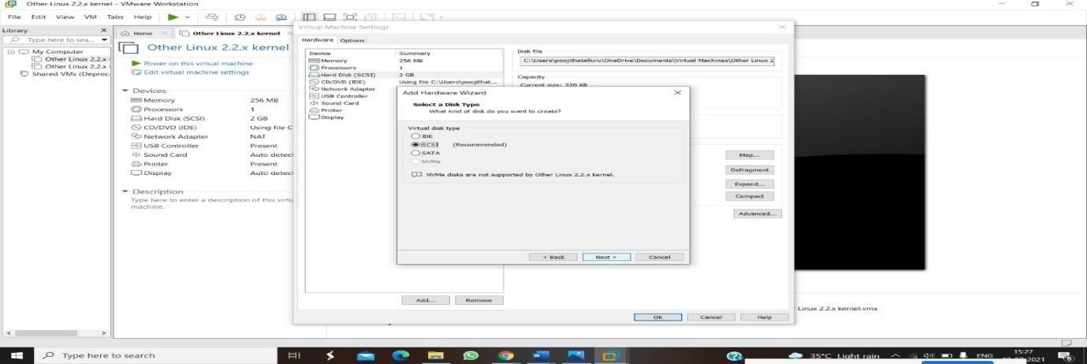

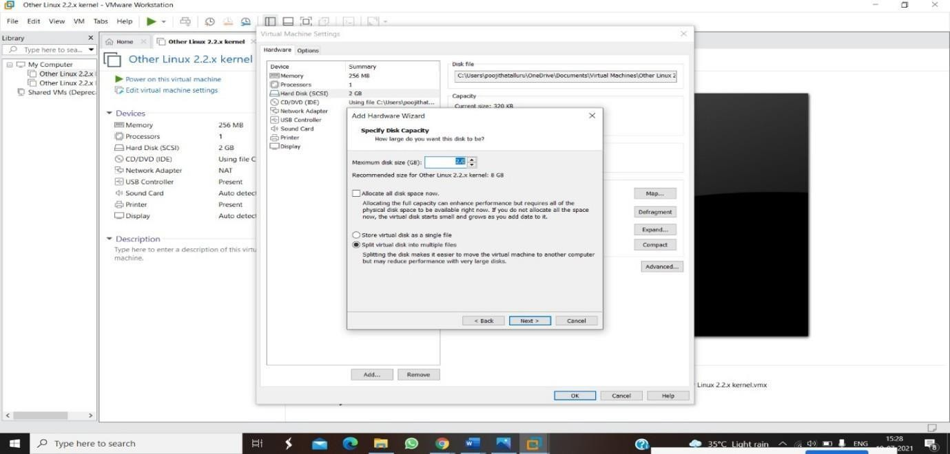**STEP 5: SELCT THE DISK SIZE AS 2.0. AND SELCT SPLIT VIRTUAL DISK INTOMULTIFILES.**

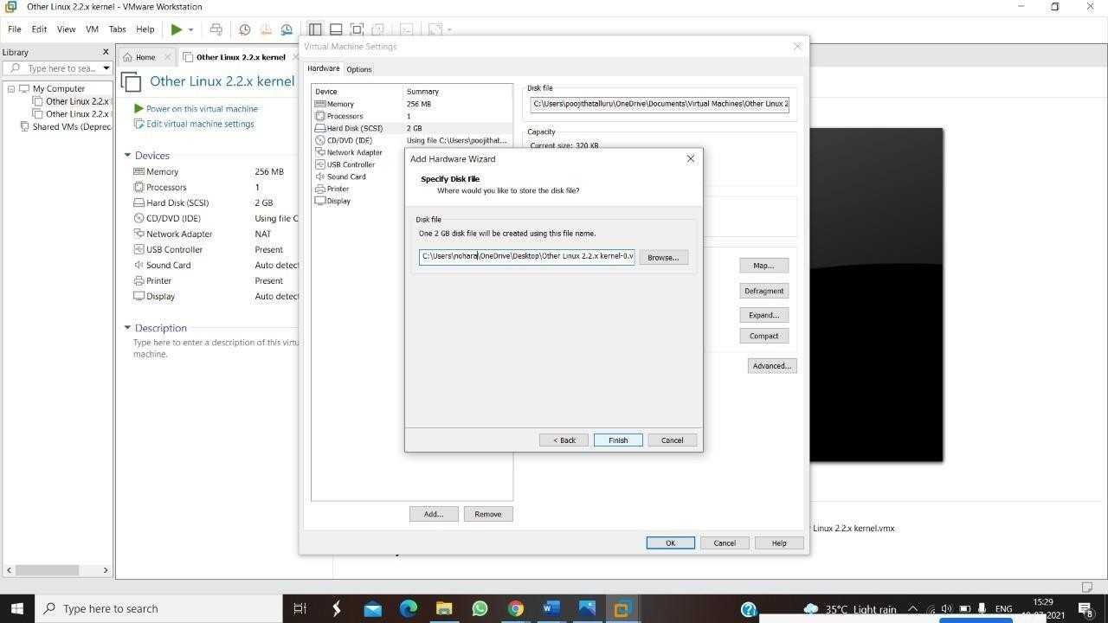

**STEP 6: GIVE NAME AND CLICK THE FINISH**